Edgy Activity - Finding MSTs in Edgy
CS4S Maths - Networks Workshop

Introduction
In this activity, you will learn how to find Mininum Spanning Trees in Graphs using these algorithms:
- Kruskal's
- Prim's
This activity will involve combining all of the Networks and Coding concepts that you have learned about in the workshop's activities. You will also learn how to sort edges in a Graph and about Priority Queues, which are a Collection that are similar to Lists and Stacks.

The Project
The project that you create today will be a program that will find a Minimum Spanning Tree in any Graph.
We will start with a Graph that looks like the one on the left in the image below. Note that all of the edges in that Graph are green. Then, after running the program, the edges that are part of the Minimum Spanning Tree will be coloured red, as shown on the right in the image below.
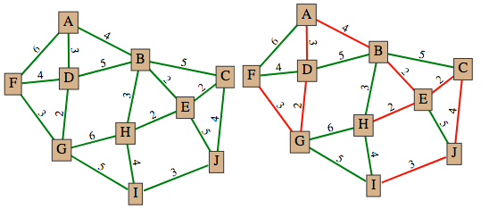
The finished program is available to download as an XML file from this link. Note, that Edgy does not currently allow you to sign in with a Cloud Account, so you can save the project you create today by exporting the final project as an XML file and sending it to yourself via email or putting it on a USB drive.

Finding Minimum Spanning Trees
In this section, we will briefly remind you of what Trees and Minimum Spanning Trees are.

Trees
Trees are Graphs that are acyclic (contain no cycles) and that are connected (there is at least one path from every node to every other node in the Graph). Trees have n-1 edges, where n is the number of nodes in the Graph and are undirected (the edges have no direction). We will look at Sub-Graphs, within a given Graph, that are Trees.

Minimum Spanning Trees
Minimum Spanning Trees (MSTs) are special types of Trees that for a Graph G:
- Connect all of the nodes in that Graph G
- Contain the edges which produce the lowest possible total of edge weights, while still being a Tree
Minimum Spanning Trees are mentioned in the MS-N1 Networks and Paths Course Content for the Mathematics Standard Year 12 Syllabus. The Course Content section N1.2: Shortest paths mentions that students should be able to:
- determine the Minimum Spanning Tree of a given Network with weighted edges (ACMGM101, ACMGM102)
  - determine the Minimum Spanning Tree by using Kruskal's or Prim's algorithms or by inspection
  - determine the definition of a Tree and a Minimum Spanning Tree for a given Network
We will implement both algorithms (Kruskal's and Prim's) today in Edgy and demonstrate how a computer can quickly find an MST on larger Graphs, where it may not be possible (or very difficult) to find an MST by inspection.

Coding the MST Algorithms in Edgy
We have provided the following information for Kruskal's and Prim's algorithms:
- A high-level Text Description of how the algorithm works, which does not include any Code
- A Pseudo-Code Algorithm, which explains the algorithm but does not have all of the commands that Edgy has
- A Parsons Puzzle, where you are given the blocks for the algorithm and asked to rearrange them in the right order
- The completed stack of blocks as Block Images, which are available on the Solutions page for this session, on the workshop website
It is up to you decide which approach you would like to take to complete the activity. If you already fairly familar with Coding and Networks already, we would recommend that you take the Text Description or Pseudo-Code Algorithm and implement the algorithms in Edgy Otherwise, we recommend that you try the Parsons Puzzle, where you can Whichever option you choose, you can always compare your blocks against the Block Images that are on the website, or ask us for any clarifications.
You can run the MST algorithms against the Graphs created by your create random graph block, but we would recommend using the build muddy city block to create a Graph. That block will draw a Graph in Edgy that is similar to the one that you found the MST for in the MSTS Activity on the first day of the workshop. The build muddy city block has to be imported first, however. To import the block, go to this session's (Finding MSTs in Edgy) page and download the Build Muddy City Block XML File file by right clicking on the Build Muddy City Block XML File link, selecting Save Link As.. and saving it somewhere easy to remember (for example: the Desktop). Next, go to the File menu (which looks like a blank piece of paper) in Edgy, click Import... and select the XML file you just downloaded for import. After doing this, you should have a new block in the Network section called build muddy city. When you click this block, it will create a Graph with 10 nodes and 18 edges (which are all coloured green).
In the following sections, we will assume that you have imported the build muddy city block successfully and that you will be using Kruskal's and Prim's algorithms to find a Minimum Spanning Tree on the Muddy City Graph.

Kruskal's Algorithm
Kruskal's Algorithm is a method for finding an MST that involves choosing edges in a Graph one-by-one to add to the MST. The edges are added to the MST by starting from the edges with the smallest weight.
Before moving onto the next section, create a variable named edges in mst by clicking the Make a variable button in the Variables section. This variable will be used to record how many edges have been added to the MST in Kruskal's algorithm.

Sorting Edges
You will need to sort the Graph's edges for Kruskal's algorithm, so you will learn about how to sort edges before creating the Kruskal's algorithm.
Firstly, create a variable named sorted edges through the Make a variable button in the Variables section. Next, add the following blocks to your Snap! program:
These blocks above set the sorted edges variable to a List of the edges that are sorted by their label (which is the edge weight). As the order is descending the edges with the larger edge weights will be before the edges with the smaller edge weights.

After clicking the above blocks with the Muddy City Graph, the Stage Monitor for the sorted edges variable should look like the image below:
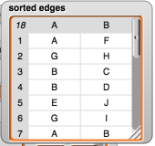
Note that the edge (A,F) is first in the sorted edges List because it is one of the edges that has the largest edge weight (6).
As Kruskal's algorithm involves choosing the edges with the smallest edge weights first, we want to change the order in the above block to ascending by selecting that option from the dropdown. After changing the option to ascending and clicking the blocks again, the Stage monitor for the sorted edges variable should look like the image below:
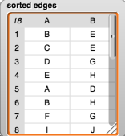
Note that the edge (B,E) is first in the sorted edges List because it is one of the edges that has the smallest edge weight (2).
In the next steps, you will use the sorting of edges as part of the Kruskal's algorithm.

Text Description
A text description of Kruskal's algorithm is as follows:
Step 1: Choose the edge of least weight.
Step 2: Choose from those edges remaining the edge of least weight which does not form a cycle with already chosen edges. (If there are several such edges, choose one arbitrarily.)
Step 3: Repeat Step 2 until n-1 edges have been chosen (where n is the number of vertices in the graph)
You are welcome to take the steps described above and create Kruskal's algorithm in Edgy. The next section explains how the algorithm works in pseudo-code.

Pseudo-Code
In the pseudo-code below, the select_edge adds the edge into the Tree that will become the Minimum Spanning Tree. For example, selecting the edge in the code below is the same as changing the colour of the edge in Edgy to red.
set edges_in_mst to 0
set sorted_edges to sorted(edges, ascending)
for each edge in sorted_edges {
if (edges_in_mst != (number_of_nodes - 1))
select_edge(edge)
edges_in_mst = edges_in_mst + 1
if graph with selected_edges is cyclic {
unselect_edge(edge)
edges_in_mst = edges_in_mst - 1
}
}
}

Parson's Problem
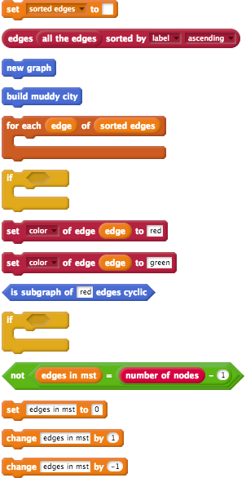

Full Blocks
A picture that shows the blocks for Kruskal's algorithm arranged in the correct order is available on the solutions page for this workshop session. You may want to compare your final result with this picture, to check if you have arranged the blocks in the right order.

Prim's Algorithm
Before moving onto the next section, create a variable named nodes in mst by clicking the Make a variable button in the Variables section. This variable will be used to record how many edges have been added to the MST in Kruskal's algorithm.

Priority Queues
Priority queues are Collections of items that are similar to Stacks. Like Stacks, Priority queues have a Function that gives us the first item in that Collection, but they work a bit differently. There are two types of Priority queues: maximum and minimum. We will focus on minimum priority queues in this activity.
Minimum priority queues have three main ways of accessing and modifying items:
- enqueue item with priority: we put the item into the queue and give it a priority value. For example: in Prim's algorithm, we will put edges in a priority queue and each edge's weight will be the priority. In Edgy, the block that does this is called enqueue item to pqueue with priority.
- head of priority queue: we take the item with the priority of lowest value and have a look at what it is. In Edgy, the block that does this is called head of pqueue.
- dequeue from priority queue: we remove the item with the priority of lowest value from the queue and discard it. In Edgy, the block that does this is called dequeue from pqueue.
To demonstrate this, use the following blocks below to create a Graph with 3 nodes and two edges:
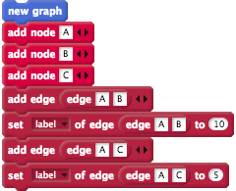
Note that the shortest edge is the one between A and C.
Next, create a variable called candidate edges, which we will make a minimum priority queue with the min pqueue block.
Use the following blocks to make the candidate edges variable a minimum pqueue and enqueue the edges.
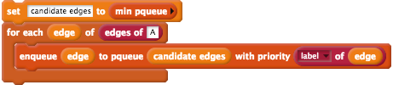

After these steps, the candidate edges variable would look similar to the table shown below:
Edge | Priority
(A,C) | 5
(A,B) | 10
Note that because the edge between A and C has the smallest priority, it is the first item in the queue.
You could then use the following block to dequeue from the candidate edges:
The candidate edges variable would then look similar to the table shown below:
Edge | Priority
(A,B) | 10
In Prim's algorithm, we look for the shortest edge that is not currently in the MST when adding eges. Consequently, using a minimum priority queue allows us to select the shortest available edge and add it to the MST.

Text Description
A text description of Prim's algorithm is as follows. Note that the T described in the steps below is the Sub-Graph that contains the MST. When the algorithm is completed, T will contain all the edges and nodes of the MST.
Step 1: Select a node to be the first node of T.
Step 2: Consider the edges which connect nodes in T to nodes outside T. Pick the one with minimum weight. Add this edge and the extra node to T. (If there are two or more edges of minimum weight, choose any one of them.)
Step 3: Repeat Step 2 until T contains every node of the Graph.

Pseudo-Code
In the pseudo-code below, mst_nodes will be similar to T in the Text Description for Prim's algorithm. The mst_nodes variable will be a List of the nodes that are in the MST.
set mst_nodes to empty list
set candidate_edges to empty minimum priority queue
add node 1 to mst_nodes
for each edge of (edges of node1) {
enqueue edge to candidate_edges with priority of (weight of (edge))
}
repeat until (length of mst_nodes = number of nodes) {
set shortest_candidate_edge to (head_of_pqueue())
dequeue from candidate_edges
set start_node to start_node_of(shortest_candidate_edge)
set end_node to end_node_of
if (mst_nodes.contains(start_node) and !(mst_nodes.contains(end_node)) {
add end_node to mst_nodes
select_edge(shortest_candidate_edge)
for each new_candidate_edge of (edges of end_node) {
new_candidate_edge to candidate_edges with priority of (weight of (new_candidate_edge))
}
}
}

Parsons' Problem
We have separated this section into two sub-sections.
The first sub-section are the blocks that will be arranged to perform the initial steps of Prim's algorithm (in the Pseudo-Code above, this is the steps from the start of the pseudo-code until the repeat until command). The initial steps of the Prim's algorithm involve adding the first node in the Graph to a List and then adding all of that node's neighbours to the priority queue called candidate edges with their edge weight as the priority.
The second sub-section are the blocks that add the nodes to the mst nodes List, as we select new edges to be part of the MST. In the Pseudo-Code above, these are the steps from the repeat until command until the end of the pseudo-code.

Initial Steps
These are the blocks to be used for the initial steps of Prim's algorithm.
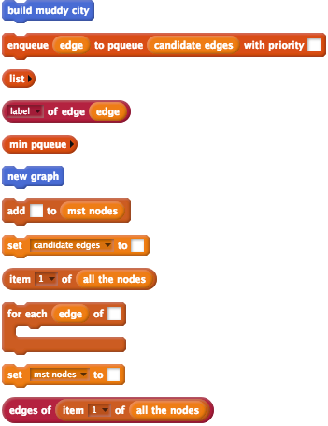

Adding Nodes and Edges
These are the blocks to be used for selecting the nodes and edges in the MST during Prim's algorithm. These will be added after the blocks you created for the initial steps of the Prim's algorithm.
Note that you will need to create a variable called shortest candidate edge for this section.
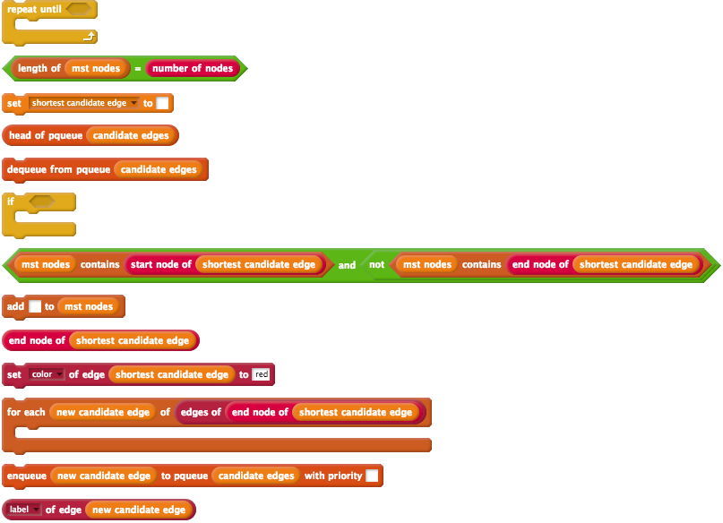

Full Blocks
A picture that shows the blocks for Prim's algorithm arranged in the correct order is available on the solutions page for this workshop session. You may want to compare your final result with this picture, to check if you have arranged the blocks in the right order.

Extension Activity: Reverse Deletion
If you complete the Prim's and Kruskal's algorithms in Edgy before the end of the session and would like to learn about other approaches for finding MSTs, we recommend that you try to implement the Reverse Deletion algorithm in Edgy.
Reverse Deletion is an approach for finding an MST in a Graph where all of the edges are included in the MST to begin with. Edges are removed from the MST one-by-one in order from the edges with largest edge weights to the edges with the smallest edge weights. Each time an edge is removed from the MST, the algorithm checks whether removing the edge causes the MST to become disconnected, and if so, the edge is added back in to the MST. This approach is almost an opposite of the Kruskal's algorithm, as we are removing edges to the MST, instead of adding edges.
An image with the stack of blocks that implements the Reverse Deletion algorithm is also available on the Solutions page for this workshop session.

Conclusion
In this activity, you have learned how to find Mininum Spanning Trees in Graphs using these algorithms:
- Kruskal's
- Prim's
This activity combined all of the Networks and Coding concepts that you have learned about in the workshop's activities. You also learned how to sort edges in a Graph and about Priority Queues, which are a Collection that are similar to Lists and Stacks.
The finished program is available to download as an XML file from this link for you to refer to after the workshop.

